Quadratic Equation

Quick link: -https://dotnetfiddle.net/zqslEu

# Group 5

**Team leader: -**

* Parth Chandgadhiya – [300986134]

**Team members: -**

* Ayush patel – [300987477]
* Rajvi monpara – [300978474]
* Rikin patel- [300983087]
* **Steps:-**
* 1. Write quadratic equation in Standard form ax2+ bx + c.
* 2. Determine the value of a, b and c.
* 3. Find D (Delta) = b2 – 4ac.
* 4. What is the value of D?
* a. b2 – 4ac > 0 (i.e. positive)
* root1 = -b +√b2 – 4ac /2a
* root2 = -b -√b2 – 4ac /2a
* b. b2 – 4ac = 0
* root1 = root2 =-b/2a
* c. b2 – 4ac < 0 (i.e. negative)
* roots are not possible
* 5. Roots are found.
* 6. End

# Flowchart:-



# Code: -

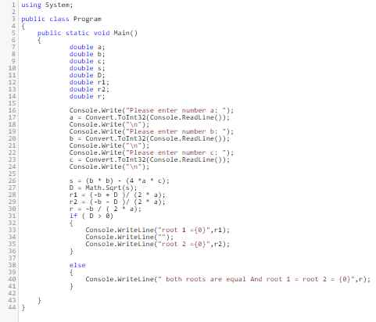

# Output 1: - D > 0 [a=5, b=6, c=1]

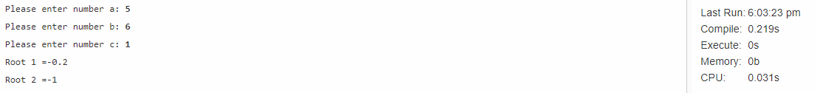

# Output 2: -D = 0 [a=2, b=4, c=2]

